

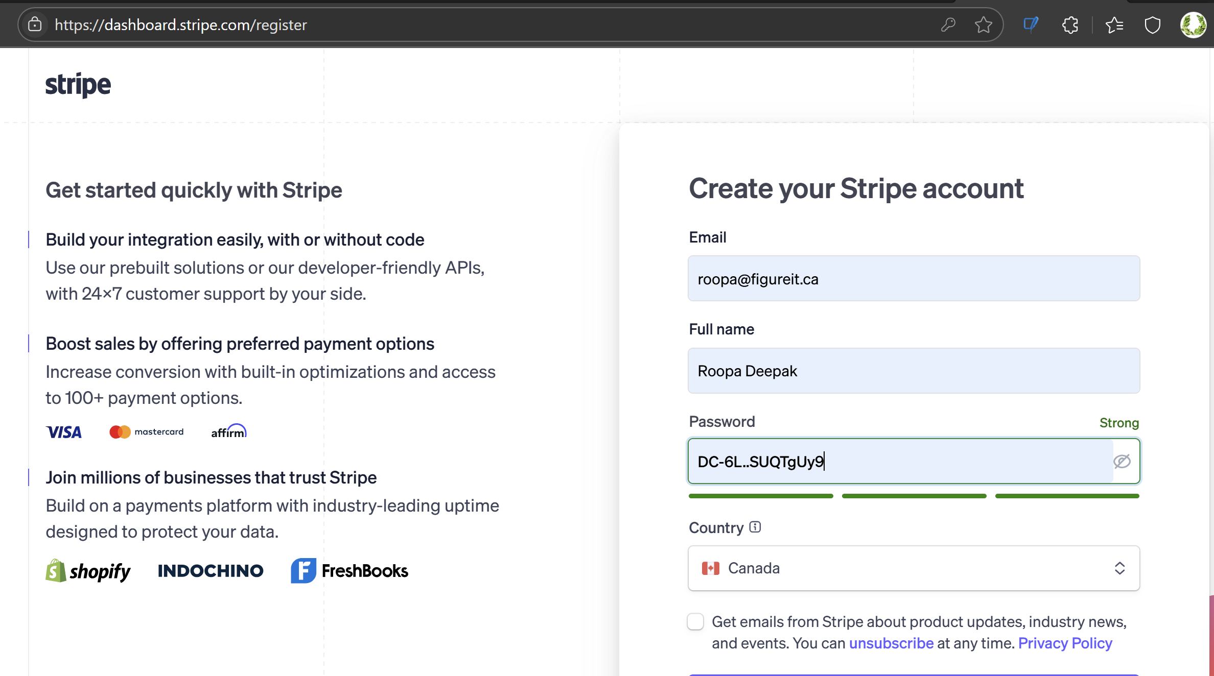
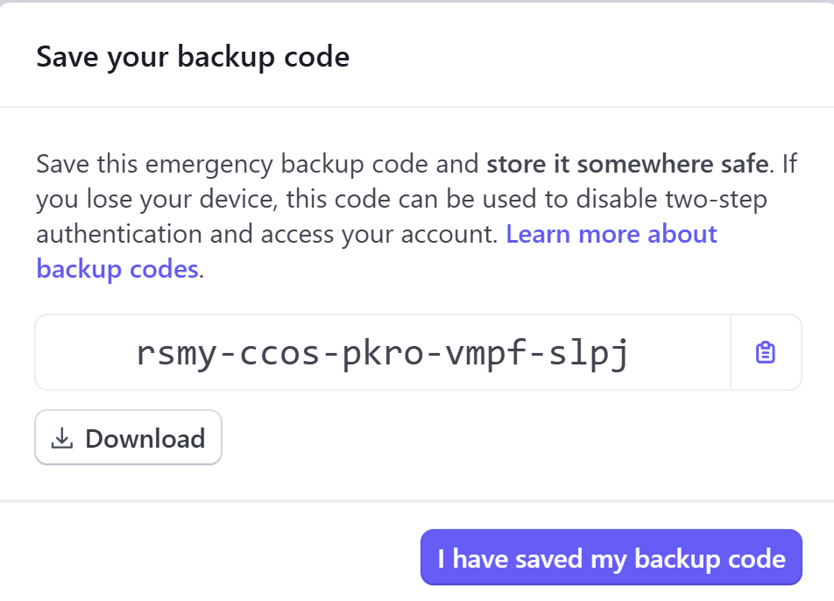

🧪 Testing with Stripe Test Cards:
Card Number: 4242 4242 4242 4242
Expiry: Any future date
CVC: Any 3 digits
ZIP: Any 5 digits

